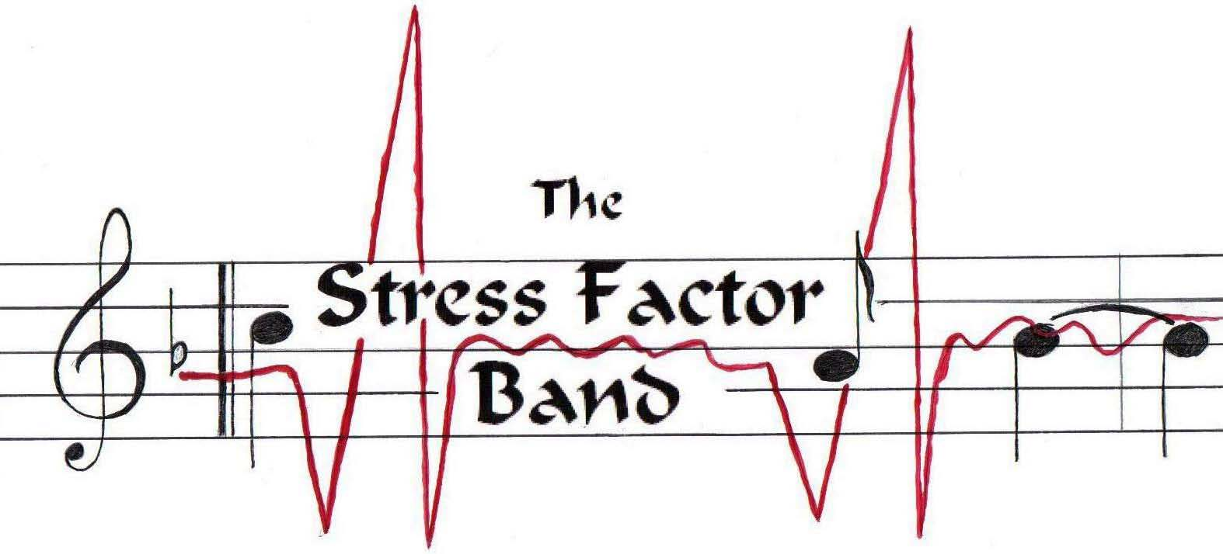
www.stressfactorband.com
Phone # 215-353-7078

Thank you for requesting information on the Stress Factor Band. The band has been in existence for ten years and throughout that time has been evolving into the group that exists today. We are made up of a very diverse group and each musician brings his own musical influences to the band. The band consists of six men and each sings lead and backup vocals. This gives the band a unique sound and a lot of diversity. Based in Hilltown Pa., we have played many local and not-so-local bars and clubs. Some of the clubs we have played are: Flanigans Boathouse, The Wagon Wheel Tavern, The Crossroads Tavern, Big Heads, Margaritas, The Red Stallion, The Rosemore Pub, The Country Tavern, Taylor’s Grill & Bar, and The Desmond Hotel. Some charitys that we sponser are the Bucks County Special Needs (6) years and the Conshohocken Fun Fest (2) years. Here are some quick facts about the members that you might like to know:

Bill Seitzinger: Lead and rhythm guitars, lead and backup vocals.
Bill, one of the original founding members, has been playing for 30 years honing his skills on southern and classic rock. Bill is usually responsible for making sure that the harmonies are tight and the set lists are “dance friendly”.

Dave McClure: Drums, lead and backup vocals.
Dave, one of the original founding members has been playing for 30 years. Dave maintains the solid rhythm and anchors the rhythm section. Dave is responsible for the day to day workings of the band, bookings, maintaining the website and equipment.

Nate Grove: bass, keyboards, lead and backup vocals.
Nate has played with several groups in the Philly R&B scene. Noteable acts include Patti Labelle and the Delfonics. Nate brings a powerful voice and tremendous stage presence to every performance.

Larry Peirce: Lead and rhythm guitars, lead and backup vocals.
Larry was formally trained at Berklee and brings a unique sound to the band. Larry is comfortable playing many styles of music. He is arguably one of the best guitarists on the Philly area cover band circuit today.

Ken Ferrier: Harmonica, percussion, lead and backup vocals.
Ken’s Petty-like vocals allow us to play music that many bands cannot cover. Ken plays a tight blues harmonica and a variety of percussion instruments.

Jim Yeager: Lead and backing vocals, percussion, keyboards, guitar,.
Jim, a multi-talented singer, songwriter, and performer has toured and recorded with a number of original bands. Jim gets the crowd going and keeps them on their feet all night.

